**SHIMONI DEMONSTRATION SCHOOL- KIRA**

**MID TERM TW0 EXAMINATIONS, 2023**

**MIDDLE CLASS, HEALTH HABITS**

**Name ________________________________________________**

1. Read and match.

eyes 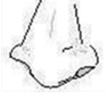

tongue 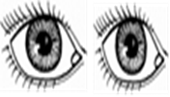

ears 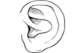

nose 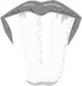

1. Read and draw.

|  |  |  |
| --- | --- | --- |
| eyes | nose | tongue |
|  |  |  |

1. Match body parts to their senses.

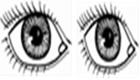 tasting

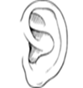 seeing

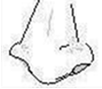

hearing

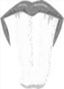 smelling .

1. Name the pictures.

|  |  |  |  |
| --- | --- | --- | --- |
|  |  | **soap** |  |
|  |  |  |  |

**(towel, sponge, water, soap)**

1. Circle the same pictures.

  

